LAB Logbook

Lab 1

Lab 2

“95.8”

Lab 3

Lab 4

Lab 5

Lab 6

Optimal number of Epochs is 4

Lab 7

40

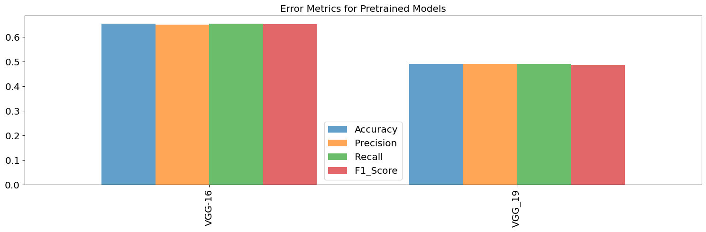

Lab 8

Lab 9



Lab 10

Lab 11

Lab 12

